West Hull Ladies
RRC

May Newsletter

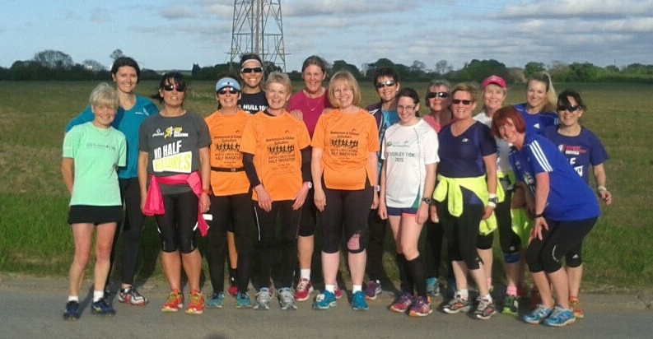

Away night: May 13th, Cottingham

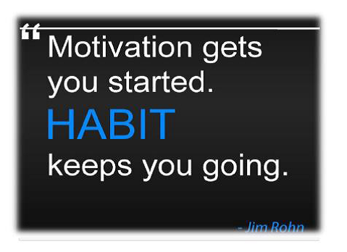

West Hull Ladies Club Meeting

West Hull Ladies
Club Meeting 11th May 2015

Minutes
Present - Maria, Jill, Jan, Liz, Sandra, Anna Karen, Linda, Amanda, Zoe.

- Apologies from Annette
- Minutes of previous meeting accepted as accurate record.
- Matters arising - Sandra had forwarded details of the GB relay to Anna for inclusion in the newsletter. Liz was still in the process of costing a second Club Banner.
- A Discussion took place about the Club Vests and it was decided that Sandra contact a different supplier and see if we were able to ‘test drive’ a vest to ensure that it did not cause chafing under the arms as the ones we use now do. The stock of Club vests to be sold for £10. Action - Sandra to source vest - Maria to email members on the sale of vests.
- Jill mentioned that many Club members were not showing up on the Run Britain site, which is what is used for certain annual Club awards. Action Jill to contact members about this. It had also been noted that on some sites we were known as West Hull Runners. Action Karen to investigate this and try to resolve, Anna to ensure that at the bottom of the Newsletter there was a note asking ladies to use ‘West Hull Ladies’ as the Club when entering events. Committee members then discussed a social event, which had been put in the dairy for 6th June 2015. Action Jan to ‘firm up” the arrangements and circulate to members.

Meet a Member

Name. Diane Pickering

Age. 44
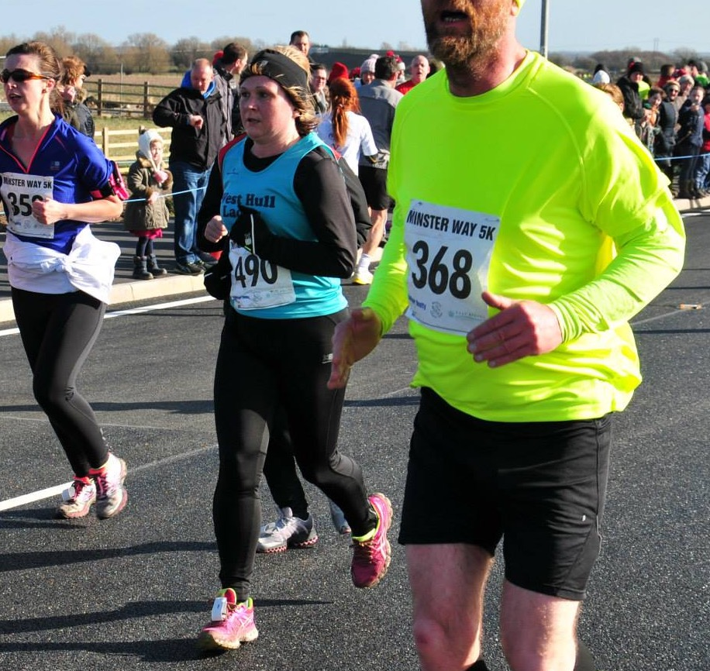

Member of WHL since – April 2014

What do you do when you’re not running?
I work full time as a community nurse for a rehab team and I'm married to Lee and have two grown up daughters who all join me very occasionally for a run! I enjoy all sorts of fitness and vary between the gym and various weights and cardio classes depending on what shift I'm working. My newest hobby is training with a Roller Derby team which is great fun.

How long have you been running?
After many failed attempts I made it my goal early in 2013 to conquer it and have been running ever since apart from a six month break through illness.

Why did you start running?
For a different fitness/weight loss activity that I could do any place and anytime. A Parkrun was advertised not far from where I live (Peter pan) and my goal was to be able to complete it without stopping.

Favourite distance ?
10k long enough to challenge but short enough to recover quickly.

Favourite bit of running kit -
I always love a new pair of trainers! I'm awaiting delivery of a Polar GPS watch which I'm sure will become my favourite bit of kit.

Any injuries?
I had a knee injury in the new year but followed the advice of other club ladies (rest, ice, foam roller and build back up gradually) and am now fully recovered.

Running goals?
My goal posts keep moving. My initial goal was a Parkrun, then it was to beat my times at Parkrun, then it was a 10k, then it was to run 10k under an hour. I'm sticking to 10ks at the minute but won't rule out a half marathon in the future. My main goal however is to enjoy it and stay injury free.

Proudest moment running related or otherwise
I'm always proud of any PB and proud to wear my WHL vest in races but recently my proud moment has to be my award for winning the West Hull Ladies 10k series 2014.

Best piece of advice you’ve received
Run regularly. Build up distances and pace gradually.

Running alone or with friends?
Always better to have company!

What keeps you motivated?
Following a period of illness I had in 2013/2014 I no longer take my health for granted. Going out for a run is a good way to de-stress and I never regret going out for a run! I'm always inspired by other West Hull Ladies' achievements. All these things help to keep me motivated.

Marathon Success
We had 11 ladies run marathons over the last month. I think we have around 55 ladies registered for the club … which means 20% of the club have just run a marathon! Amazing work ladies!

12th April Brighton - Rachel A
19th April Manchester - Sally, Jan, Liz
20th April Boston - Sandra
26th April London - Jill, Karen, Debbie, Sara, Rachael, Jill C

Sally 3:52 Manchester
Sandra 4:02 Boston, USA
Debbie 4:03 London
Rachael A 4:05 Brighton
Sara 4:10 London
Rach 4:10 London
Liz D 4:24 Manchester
Jan 4:31 Manchester
Jill J 4:31 London
Jill C 4:38 London
Karen 5:47 London

Boston Marathon- Sandra

I was running the Boston Marathon and looking forward to it - until the weather started. Looking at weather reports it was forecast to rain at 2pm. I was quite happy with this thinking that by then I would be well into the run and be thinking of finishing. The rain might be a welcome respite. How wrong was I?

The marathon starts at a place called Hopkinton and most runners are shipped in using the yellow school buses which most of us are familiar with. Seeing all these buses lined up at Boston Common on the morning was a sight to behold. Hundreds of them ready to transport us to the Athletes Village.

We were all given start times according to the times we had submitted in order to gain a place. To run Boston you must have a qualifying time. I have to say that this made the running good as you were in a starting wave/corral with runners of the same standard.
So about 7.45am I was on my way wearing the statutory dustbin liner. I was sat next to a lady who gave me some heated hand warmers. What a god send there were for me. I had one in my sock and one up my sleeve. The weather was very cold and the forecast had been wrong. About 8am it started throwing it down. Not good for my enthusiasm.

The journey was about an hour and on leaving the bus I joined the queues for the statutory toilet stop. At this point it was so cold and wet volunteers were handing out heat blankets. I gladly took one. I then went into one of the tightly packed tents - sat on some cardboard on the floor and waited for my wave/corral to be called to walk to the start. This wasn’t how it was supposed to be. I could feel myself losing all my enthusiasm - I really didn’t want to run in these conditions, cold and rain. I like the sun and was only dressed for that! Big lesson - pack for all eventualities. I didn’t and just had my WHL vest and shorts, thin running sleeves, cotton gloves - snood, headband and sunglasses! No wet weather gear - oops!

So after 2 hours in the village my wave was called out and I joined all the other runners for the mile walk to the start. We walked down a narrow street so were tightly packed. It was amazing, most residents had come out of their homes to cheer us on. This was before we had done anything and was an indication of what support there would be around the course. My mind-set to run wasn’t the best. My last Marathon had been York last October. For that I had felt bouncy and ready to run; now I felt flat and just didn’t want to do the 26.2 miles, which lay ahead of me. I tried to tell myself that this was an iconic marathon lots of people would love to run but I still struggled to look forward to it.

At this point I could have done with another toilet stop but the queues were long and I liked it better being in the middle of a group of people. Most of the runners I spoke to were American or Canadian still having travelled long distances. I did manage to find another English lady from Solihull.

So at 1050hrs I was off.

My plan was to start off slowly so that I was ready to face the hills that start at about 16.5 miles until 21miles. I stayed in the middle of the pack so was able to do this. The route stayed on quite narrow roads so for quite a while we were bunched. This however was okay and didn’t cause a problem. More queues for toilets at mile 1 so I continued to mile 2. More queues and after waiting a while another lady and myself went between some parked cars. Not the best but better then waiting.

So I was running and trying hard not to be negative about it. Look around you Sandra - see the beautiful scenery and it was. We ran along tree-lined roads with lakes, lovely towns with the different coloured weather boarded homes. I was having a free tour of the wonderful New England towns and countryside.

Drink stations were every mile on both sides of the road. Cups of Gatorade and water were handed out. To drink these you had to stop. The lines of volunteers were amazing and the supporters out of this world. It was cold and raining but still they were out in 1000’s cheering us on by name. I kept hearing my name being called out constantly and then I saw another runner named Sandra running to one side of me!

I was surprised about how undulating the course was. I thought the ‘real hills’ didn’t start until Newton at 16.5 miles. Maybe hills were more accentuated as you could see all the runners up ahead climbing.

So I was feeling quite good running wise - but coming up to the half way mark at Wellesley I was looking forward to having WHL with me holding my hand. Until you are out there doing this you don’t realise how much this helps. I was trying to think who would be there and had you taking it in turns dragging me on! Thank you ladies.

I reached the hills and was pleasantly surprised - they were fine. In fact I had more trouble getting up the last hill in York then I did these. However mile 20-21 took me just under 10 mins. It was the steep downhill at mile 22 that really hurt my quads - such a shame not being able to make use of the downhill. It was so painful and I tried to figure out why if my arms and legs were numb with the cold and rain I could still feel pain in my legs. At one point I took my soggy white gloves off - they were wringing wet through but they did give me some warmth so I had to put them back on.

Thinking I may make the 4hours I tried to push on but it wasn’t to be. I should not have focused on my Garmin as that had my distance at the end as being 26.48. I didn’t think I had as far to go as I in fact I did so I managed 4.02.54.

The support all the way round had been fantastic but from Mile 23 it was something else. Many had left Fenway Park home of the Red Sox baseball team and had stayed to cheer us on. The run to the finish was surreal - come on Sandra - smile - punch the air - you are Boston strong. Try to get a better photo !!

I did read that running Boston is akin to doing a victory lap. Everyone knows you have done the hard training and to run the course is to be celebrated and you are cheered extremely loudly throughout 26.2 miles.

So in all honesty whilst I was running I didn’t feel as happy as I thought I should. I really need to sort myself out about running in bad weather - I let it spoil my experience. But the run itself didn’t hurt like others I have done so…………..

All in all it was a wonderful experience.

Boston itself was fabulous and I had a great week way. I did say that I would do the Marathons that I have booked (Berlin and London 2016) and that would be it but………. Chicago 2016 looks good or maybe give Boston another go in 2017 if I get the qualifying time!
Sandra
"My Manchester Marathon: Mums story"
Jan
Training had gone well, on the whole, although I always feel I’ve never done enough. Going down with Shingles over Easter didn’t help either. But despite a slight hiccup with race numbers (I’d managed to register both Liz and me under my name) we were both feeling excited. A lovely pasta dish cooked by Liz the evening before set us up and we were ready and raring to go.
We had an early start, setting off at 6am to drive to Old Trafford. Despite a very minor detour (came off the motorway at the wrong junction!) we arrived safe and sound, parked where we had parked last year and walked the half mile or so to race HQ. After queuing some time for the loos – a key ritual for all runners! – we dropped bags off (which included my post-race drink (Stella!), crisps and Liz’s favourite, a Snickers bar) and headed to the start line with Sally Widdowson. We said quickly goodbye to Sally in the 3.30 pacer area and made our way further back. And then we were off…

We have made a hobby and habit out of our shared love of running but we are always comfortable running our own races. So we ran together for the first 3 or 4 miles, running at a steady 9.30 min/mile pace. We gradually lost each other and I moved on ahead slightly. The course is relatively flat with great support along the way, so the first 8-9 miles felt ok. The route then incorporates a two-way stretch until about mile 16 when us slower runners on the ‘out’ stretch can see all the faster runners coming back on the ‘return’ stretch. Looking out for Sally and City of Hull vests – they were out in force – was a great distraction and helped to pass the miles. I saw Rich Harrison and was able to ‘hi 5’ him and although I missed Sally, Liz saw her looking strong near the 3.30 pacers. I hit half way about 2.02 and was feeling steady.

In my marathon running, I have always found it difficult to balance hydration and nutrition – balancing the need to keep hydrated and energy levels up with the frequent problem of feeling sick and getting a stitch. So over the years I’ve experimented with lots of different approaches, settling on sips of water (carried in a Nathan waist belt) and Torq energy bars. I have also learned the hard way never to do anything different on race day. I think a marathon only really starts after mile 15/16 but I was holding my own and doing 9.45 minute miles, slowing gradually to 10-10.15 by about mile 20. And then this is where I started to find it tough. Quads started to tighten and my head started to tempt me into walking. The 4.15 pacers passed me somewhere about this stage and then at about mile 21/22, I heard a voice behind me say ‘Hi mum’!

And boy, she looked so strong – very different to how I was feeling. ‘Come on mum’, she said, ‘Let’s run the rest together’. So that’s what we tried to do and we managed a mile perhaps before my quads started shouting! I needed to run/walk much more than I would have liked, so Liz ran on ahead, looking really great. I was so proud of her, and although she had really tried to encourage me, I knew what beating mum really meant to her!

The last few miles were tough but the support on the route was fantastic. I can’t tell you how welcome it was to make the final left turn and see the finish line! In the end Liz did it in 4.24, smashing her PB by 11 minutes and I made it in 4.31. It’s such a wonderful feeling of achievement, crossing the line, getting your medal and goody bag, and then being met by your daughter who is sooooooo pleased with herself!

In the past I have often felt shocking immediately post-marathon: sick, dizzy and looking like death. I have experimented to find out what combination of food and drink works to settle those symptoms and have settled on … Stella and crisps. So these are my companions in my bag on every marathon. Amanda says she can understand why the crisps work – replacing lost salt – but does not recommend the Stella! But I‘m a great believer in finding what seems to work for you and then sticking with it!
So there you have it – my Manchester marathon! It was wonderful to have the crowd shout for West Hull Ladies and I felt very proud to be wearing my vest. So, what’s next? Well, Champagne League, a few half marathons (North Lincs and Humber Bridge), various 10Ks, Endure 24 and Thunder Run (what have I done?!!) and then Hull marathon in September. I’m going to take training very seriously for this and put more emphasis on speed training as well as the weekly long run. I’m going to shed a few pounds too. Amanda reckons losing a stone equates to 1 minute per mile. Doesn’t perhaps sound a lot but when you think about it in marathon terms it could mean a difference of 26 minutes! There’s nothing like a bit of healthy rivalry between mother and daughter to keep you motivated!

"Jill J's Marathon Adventure"

I apologise as this is going to be a marathon write-up…as in lengthy, but the whole thing was such an amazing experience that it’s difficult to portray it in simple terms. From the training, the actual event and the amazing support from friends on the course and on facebook, this has been a memorable life event that will always live with me. Anyway…back to the nitty gritty. Although I’d had an injury and a bit of a cold in the run-up to the event, my training had gone really quite well by my standards, so I felt that as long as I got to the start line in reasonable shape, I would finish it by hook or by crook! In the weeks coming up to the marathon, Zoe kept bringing back various dreaded lergies from work so was tempted to put her in quarantine until after the event and after trying to sabotage myself by dropping a shower gel bottle on one foot and my full suitcase on the other, we both managed to set off on the City of Hull marathon bus early Saturday morning, in a relatively healthy state. This is a great trip because it takes all the worry out of getting there. They take you to the expo to sign on and look round; you get to see some of the sights of London as they take you to the hotel, and they get the runners to the start and any spectators/family to a good viewing point on the morning of the event. They then pick you up reasonably close to the finish and take you home again…all for the bargain price of just under ninety quid! So…the morning of the race dawns, and we all were getting obsessed by the weather in relation to what to wear in the race. I usually go for the ‘expect arctic blizzards approach’ but Zoe insisted that I should wear shorts and vest top, as London is generally warmer and more humid than sunny Hull. Arriving at the start on the coach, I was very relieved that I had packed a coat that I was going to throw away at the start, (which are collected up for charity) and a bin bag as the weather was decidedly cold and damp! (so much for hot and humid Zoe!) Me, Sara, Rachael and Debbie, then proceeded to join the toilet queues…We actually kept going to the loo and then went back and joined the back of the queue again…a bit like a toilet relay. This was quite a good strategy, but the mistake we made was to put our bags in the baggage lorry too early (fail!). London Marathon Lesson one: You don’t need to do that, as it’s an easy process to hand your bags in, and as long as you do it in time…its fine…no need to rush. What it meant was that I had to take off my tracksuit bottoms, and just stand there for well over an hour in a thin running jacket and a bin bag…it was FREEEEEEZING…yes even in London. We literally huddled together like penguins trying to keep warm…(Don’t think Paula Radcliffe had that problem, she was probably in an air conditioned tent!). Anyway the time went quite quickly and soon we were queueing to get into the starting pens. I was in pen 7 on blue start and managed to get through the start in around 10 minutes, which surprised me. The first section loops around various housing estates and there was plenty of support out. I dumped my running jacket in the first half mile, as Zoe had been right to say about running in shorts, as it was a really good running temperature…kept my gloves on though! Went past a huge (and I mean huge) dinosaur, and some guys going for the world record carrying a bobsleigh dressed as the Jamaican team (??!!). Had a really nice chat with a lovely woman called Sarah from Scotland at about mile 5, who saw my charity logo that I had pinned to the back of my shirt (NET patient foundation that look after people with rare Neuroendocrine cancers), and chatted to me about having raised money for that particular charity before. We spent about three miles running together, before she pulled away from me. I even saw Sara and Rach across from me at this point before they disappeared into the distance! Getting to the cutty sark was the first momentous landmark…and it’s even more spectacular in the flesh, than on the TV. At this point, I felt that I was running quite well…in fact I was a bit worried that I was going too fast. However I decided that within reason, the quicker I go, the quicker I get to the finish, and I know that I run more fluently when I run a bit faster so I just went with it. After the cutty sark, it was a bit of a slog…in fact I was a bit worried that my ‘fast’ early pace had been too fast, and I wasn’t even at half way. London Marathon Lesson two: This is the thing with the marathon…it plays with your head. You see the mile signs and you think, I’m finding it hard and there is still sixteen miles to go…will I get round..?? and the panic sets in… So you need to come up with some positive thoughts in advance to counteract this. By about mile 10, my feet were hurting, which is ridiculous, as I had previously done 20 miles without blisters???...and my back ached across my shoulders. At this point I thought about the young guy who I was running on behalf of, who has terminal cancer and is undergoing some horrible chemotherapy…and concluded that my aches and pains were pathetic in comparison…and to just get on with it. This did help as did talking out loud to myself to say that I was doing okay, and of course the crowd cheering which was great. Despite the multiple toilet visits before the race had begun, I then felt that I needed the toilet again. Every so many miles there are portaloos for the competitors, but there are often queues…anyway…I had put it off long enough, so decided that I really needed to go to the toilet and joined a queue…Well I won’t describe the toilet in detail apart from saying that it looked like something from the ‘Dirty Prison Protest’ (Even if you have not heard of this, I suspect you can guess what this looked like… from ceiling to floor… yuk!). The worse thing was that I then dropped my gloves onto ‘toxic mix’ that covered the floor. Even worse was I didn’t really need a wee…it ended up being a mental wee! I decided at this point that I would not pick my gloves up, and that Paula Radcliffe had had the best idea when she squatted down in the street to have a wee in one of the London Marathon races a few years ago! Fortunately my legs were still quite okay at this point so I managed to wee hovering style! I was a bit gutted about my gloves as they have been on many running journeys with me, but…there are limits, and running the rest of the way smelling of poo was not on the agenda! Having survived the perils of the portaloo, reaching Tower Bridge was a brilliant milestone as it’s just before half way. The noise is amazing and it’s such a great spectacle, so I was able to forget about my aching feet and back…I also started looking for daughter Zoe and the group of spectators from the bus as I knew that they would be standing somewhere near this area. To be honest, I was dreading this next section round the Isle of Dogs, as it is a double back section and you can see all the fast people getting to 22 miles striding along majestically, whilst you are still stumping around at mile 13 starting to do the ‘marathon waddle’ (boo!). I also thought that there would not be much support, but actually it was really good. I was so excited to see Zoe and the guys from the bus on the other side of the road…and was leaping around like a lunatic…shouting at the top of my voice. Zoe on the other hand was obviously not seeing me…Luckily Rich Harrison from City of Hull did see me leaping up and down like Zebedee from the magic roundabout, and pointed me out…so everyone was waving. This was better than drugs (not that I actually know this, you understand!!!!). I was soooo buoyed up by the fact that I had seen my friends, that the next mile seemed easy! Even sticking to the floor at the feeding stations where they were giving out gels, did not phase me one bit! Unfortunately by around mile 16-17, my feet took another turn for the worse…It was a bit like running with razor blades between my toes and my back was hurting again too!!! In hindsight, I think the problems I had with my feet were because I had pulled my socks on a bit too hard. Whilst they had felt comfortable at first, as they were new socks, as my feet got pounded it rammed my toes into the front of my socks on every step. This blistered the front of my second toe on each foot (and more…but probably best not to go into details, but suffice to say that I probably won’t be wearing open toed sandals for a bit!…big ouch!). (London Marathon Lesson three: take great care to get your socks on with some room in the toe, plus plenty of Vaseline!). Fortunately, the support in the Isle of Dogs was great and there were even some screens in one of the underpasses where you could see yourself, which was hilarious. I saw Jill C who tapped me on the shoulder and we had a bit of a chat which was great. She looked in good shape, although we both said that we were struggling a bit! I kept thinking about a number of things at this point to keep me going, for instance Verity told me to ‘enjoy it…its London after all’…so I thought I jolly well better had then!... I also thought about Edward the young man who I was running on behalf of… and visualised running up the mall to the finish… Along with this I imagined West Hull Ladies following me on the internet…about seeing Zoe at the end and giving her a hug…as well as not wanting to disappoint everyone who had sponsored me too. All of this was a great motivator, because doubts at 16-17 miles are really tough to deal with. You have around 10 miles to run…which is a long way, and it’s difficult to visualise this. Envisaging 5 or 6 miles is easier because you can think of it in terms of a 10k run, or Cottingham Alleys for 5, …3 miles is a parkrun etc…but 10 miles is pants! (Thinking Snake lane or Ferriby 10 will just not do when you are at a low ebb!) The crowds were amazing though…and the wall of noise was astounding. I think that I get pain in my back, when doing long distances because my posture is not good, so as I am running along, I also think about Sandra’s ‘doing a body MOT’ every so often to try and get me to run in a better style. Apart from this I sometimes try to imagine ‘running Like Linda’ (could be a DVD title lol!)…hopefully this does not sound too weird, but for me, I think Linda runs in a very tidy and economical style, so I try and emulate this in my head…in reality it probably doesn’t work in practice but hey ho! Planning your nutrition intake is also really important in the marathon. If you don’t want to run from toilet to toilet…see previous comments about the delights of the race portaloos [Symbol], (also ask Zoe about her Yorkshire marathon toilet to toilet exploit!...), you must go with what you are used to. I like torq gels, they taste great (Rhubarb and custard is yummy), and I also take a few salted nuts with me because I sometimes get cramp if I get low on salt. At London they provide Lucozade gels and drinks, as well as lots of water…but I don’t like the drinks or gels (and I won’t repeat Lynn’s description of gels here as children might be reading this… lol!), so I take my own round. This means that I have to take around 8 gels because I have my first gel after an hour and then eat one every half an hour until the finish. This structure also helps you to keep going, because you start to look forward to eating the gels (raspberry ripple…mmm)…so when you look at your watch you can think…in 10 minutes I can have a gel…and maybe even have a bit of a walk and that helps to keep you going too. By this point you are probably thinking that this is more about psychology than it is about your physical ability to run, and I would say I think it is: London Marathon Lesson four: For me strategy and ‘Brain fitness’ is just as important as physical fitness. This strategy got me through some low points where I started to doubt myself. For me compartmentalising the race is really helpful; at the halfway point…I tell myself that I am on the way home, mile 20 is another turning point for me as it heralds the 10k to go point, and a believe that I can do 10k even if I have to crawl it, so at that point I knew that I was going to finish come hell or high water. At London, 22 miles is particularly encouraging as just after this you turn towards the embankment, the houses of parliament and home. Where the crowds had been amazing in previous places, here it was just indescribable! Every space is covered in people cheering and shouting for you…Having your name on your vest means that people shout for you. I heard ‘come on Jill from Hull!’ loads of times…and also ‘Come on Jill…where’s Hull’(?!!?) …definitely lesson five for any marathon is to have your name on your vest. Coming onto the embankment, you can see Big Ben which is brilliant, because you know you are so close. Near to Westminster Bridge I came over to the outside as Liz Draper said she intended to stand near that area…it was fab when I saw her with her friends just before, I turned towards St James’s Park. Part of me wanted to stop and give her a hug, but I didn’t think that I would be able to start up again because at that stage your legs are on auto-pilot! Again, whilst the support from the public is fab, seeing people you know is just massive and sooo spurs you on. The run in to the finish was amazing and as you turn towards the finish the emotion is overwhelming. Not only had I run a marathon, which is special in itself, but somehow London is something much more to me at least. I’ve watched the London Marathon probably every year since it started in 1981. Almost every year I have thought how amazing it would be to run it, but never thought that I would actually do it. Even when I started to do a bit of running, when I had my mid-life crisis at the age of 41, when I thought running a mile without stopping was massive, and running my first 10k in 2010 was a superhuman feat (which it is when you go from doing no running at all!), it was not until I joined West Hull Ladies that I actually thought that running a marathon was possible for me. When I first joined I thought you were all bonkers, doing the mileage that you were doing. The fear that I felt, the evening that I came for the first time on a particular Wednesday, when I thought that I might just manage 5 miles without spontaneously combusting, and everybody was doing between 8 and 12…is engraved on my memory. I managed seven and a half that night, and wondered how on earth people ran further than this as my feet were just about falling off. Fortunately you all converted me and now I’m glad to be bonkers too…cos I wouldn’t be sat here as proud as punch with a London Marathon Finishers tee shirt and medal, two days after my 54th birthday, had I not joined West Hull Ladies.
Jill xx

Leeds Half Marathon
Tracey

Leeds Half Marathon – Sunday 10th May 2015
I was up at 6am on Sunday morning, porridge and banana for brekki, left home at 7.15 to drive to Leeds on my own, found a very cheap parking space £2, walked up to the Millennium Square at about 8.15, even at this time the atmosphere was buzzing. I was a yellow runner and was told to make my way to the yellow zone once I’d dropped off my bag. I got chatting to a few other people, even though I was on my own it didn’t feel like I was. At about 9am the crowds were gathering in Headrow and in the Millennium Square all cheering & shouting. At 9.15 the crowds of green and yellow runners started with a warm up led by a coach who was up on the stage with a mic, by this time the atmosphere was tense but electric. At 9.30 the green runners were led by the marshalls to the start line, at 9.40 the yellow runners were told to make their way to the start line, again led by the marshalls. The sun was beaming down on us, it was really hot, I made a quick decision to take my long sleeved top off & wrap it around my waist, I felt a little naked with just my WHL vest on … showing my arms, it’s been a long time since I wore just my vest!
Walking up to the start line seemed to take forever, I just wanted to run. More crowds gathered shouting and cheering, there were runners dressed in all sorts of weird and wonderful costumes … fairies, sailor and even a carrot; everyone seemed to be in good spirit.
I eventually reached the start and off I went along with hundreds of others, pounding through the city centre with the crowds still shouting and cheering. I tried to overtake a few people but it was impossible, just too many runners gathered together. As we made our way out of the centre I started to pick up my pace but still not fast enough due to the crowds of runners. The first 2 miles were up hill, then probably ½ a mile down hill then 3 ½ -4 miles up hill, not huge hills but long inclines, just when I thought that must be the last one I could see another in the distance! Even at 4/5 miles it was still a struggle to overtake, I was on and off the pavements just to try and gain some speed. Crowds lined the pavements, cheering, shouting, dancing, playing music, playing instruments and waving banners. At about half way I could hear bagpipes, a band stood on the green playing … this made me feel very emotional but I then thought about WHL, thinking that you will all be starting the Bev 10k, this really inspired me knowing we were all running together, even if in different cities!
At this point I heard the crowds saying “that’s it now, it’s all down hill”, I knew this was the time to increase my speed and catch up with my time. I raced ahead, grabbing water at the stations, I think I poured more water over my body than I drank, it was still really hot, residents who were watering their gardens sprayed their hose pipes into the streets, many runners, including myself, ran through them, it felt great.
The crowds continued to cheer, another band played African drums down one of the main roads, at about the 9/10 mile point. Many runners had stopped, started to walk, stopped to stretched and some had fainted, not sure if this was due to the heat or just exhaustion, there seemed to be plenty of ambulances and medic cars racing by, I just hope that these people are ok.
At mile 11/12 I still felt strong, my breathing and posture all seemed on track. Racing back into the city centre was awesome, I couldn’t believe the amount of people that had turned out to support us. The atmosphere was electrifying, however, that last ½ a mile I started to struggle, the people were shouting & cheering “not long now, you can do it, it’s just round the corner ….”, at this point I gave everything I had and pushed myself, checking my garmin, I knew I wanted to get in at under 2 hours, with only a few minutes left, I picked up my pace, looked ahead at the finish line and ran like the wind … crossing the finish line in 1:58:23!
Despite the hills I loved every minute, very well organised, great support & encouragement from the crowds and a lovely t-shirt and medal. Thanks to everyone involved. I hope to see some WHL next year!
Tracy

Lincolnshire Half Marathon

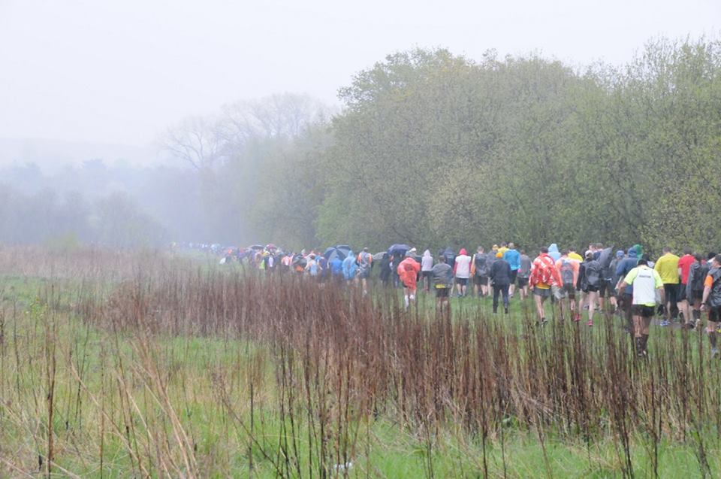

Lincolnshire Half Marathon

Andrea

When everyone on Facebook started posting about how they’d entered the North Lincs half and how brilliant it was, I got caught up in the excitement and entered too. So three months later, the morning of my first half marathon dawned. At 5.30 (when I got out of bed!) it wasn’t raining. Thank goodness, the forecast had been terrible. Unfortunately, about 10 minutes later, the rain started to fall. It was ok though, because I had packed a bin bag to wear at the start, along with most of my wardrobe and the kitchen sink – you can never be too careful.

Karen picked me up in her car at around 6.30 (thank you for driving Karen) Barbara and Jane were already in the car. It was lovely to have the company and we all chatted about Karen’s marathon the week before and generally moaned about the rain, which was heavy now.

We arrived at Scunthorpe United football ground in plenty of time to meet up with the other West Hull Ladies; to have photos taken, have several trips to the toilet and to don our binbags. My nerves were really starting to kick in; the weather didn’t help, and although I felt that I’d prepared well for the run, realisation of what I was about to attempt was dawning. Fortunately there were plenty of lovely ladies to talk to which really helped.

The walk to the start was quite long and wet (have I mentioned it was raining?) but I lined up alongside Liz and Sarah JW. We decided that we would set off together and see how it went. Eventually after a long, wet, cold wait we were off. Liz, Sarah and I stayed together for a couple of miles then Sarah pulled ahead. She had been worried beforehand as she felt she hadn’t done quite enough miles in preparation, but I’d been positive she would be fine – and she was – running really strongly. Liz and I stayed together for another mile or so until I started to drop back, leaving Liz chatting to a chap with a beard. I kept Liz in my sights for most of the rest of the race but couldn’t catch her up again.

The heavy rain eventually stopped and became drizzle and then started and stopped again. I entertained myself with counting down the miles and when I really started to struggle around 7 miles I started counting to 500 and then checking my Garmin to see how far I’d gone whilst counting!! The support from the marshals and spectators was absolutely fantastic and really helped me to keep going (although I was always going to finish unless I physically couldn’t get to the end) The group of children on the drinks station at the village of Burringham were particularly fantastic; by the time I got there they must have been stood there for over 2 hours; but they all shouted encouragement. One boy shouted ‘you can do it Andrea!’ which nearly made me cry! (well I was wet and tired!!)

Finally, I was in my last couple of miles. This bit is memorable for me for two reasons – the first is when I heard someone coming up behind me puffing and panting, only to be then over taken by an elderly gentleman, who was almost bent double, who was WALKING!!!! I didn’t know whether to laugh or cry – I think I did both!! And the second was when I got close enough to the finish to hear the loud speakers. I got goosebumps as I knew I the end was almost in sight and I could look forward to running over the finish line. Unfortunately someone had put in a really nasty steep little footpath over the road which had to be managed first, but once I’d struggled over it, it was downhill all the way into the stadium and over the finish line. I’d completed my first (only??) half marathon. It was so much harder than I ever thought it would be. I found it much harder than I had my training runs and I’d run up to 12 miles then. After 7 miles it really was a case of gritting my teeth and keeping moving. However, it was brilliant to see all the other West Hull Ladies at the finish and to exchange hugs and congratulations and have more pictures taken. The cake and the goody bag at the end were fab too and I have a real sense of achievement. I really do think it should be acceptable to wear your medal for longer though - I wanted to wear mine for work the week after but thought better of it.

Congratulations to the rest of the ladies who finished in brilliant times. And a big thank you to Sarah K, Sarah JW and Jermaine who ran with me on my longer runs with me. I definitely wouldn’t have even dreamed of attempting a half marathon before I joined West Hull Ladies. Thanks to all of you for your help and support. Will I do another one?? Erm…..I’ll get back to you on that one!
Andrea

Lincolnshire Half Marathon

Linda

When I woke this morning it was very windy but at least it was dry. The weather forecast said rain so I packed my bag with all eventualities catered for. I needn’t have bothered though just my usual winter running kit required as the rain started before I’d even reached the Humber Bridge car park! I wonder when I will be able to wear any summer running gear?

Upon arrival at race HQ we quickly gathered for photo’s near the baggage area, no-one was keen to go outside. Thank goodness for bin bags, thought I might be running the whole race in mine!

Then it was time to leave for the long walk to the start, by now the rain was hammering down, poor Maria she only had on a vest and shorts although she said she preferred it that way! By the time the starter hotter went off we were already soaked and miserable and so cold. But we are WHL we are tough! I did run for a short while in my lovely green bin bag for around a mile then off it came. By the time the race was over I was totally drenched, my feet were squelching in my trainers but I thoroughly enjoyed the race. Can’t believe I got third female 60 so another trophy sits proudly on my windowsill.

What I would like to say is that I felt very proud to have been part of all the West Hull Ladies that joined the start line, I think there were 21 of us, some doing a half for the very first time. Hats off to them and under these conditions too. Everyone did our club proud. Wherever we walked people were cheering us, especially the Hull marathon table, we got such a good reception. During the race all the marshalls and supporters shouting out our club, it was fantastic. Getting to the finish to WHL smiley faces cheering us in and then cheering in all our other ladies. Seeing Sandra receive her trophy for coming second lady in her age group, amazing.

Lincolnshire Half Marathon

Lynn

Before…..
Got up. – wished I hadn’t
Got there, got wet, got cold, adrenaline already kicked in so didn’t care.
During….
Got even wetter, had a stream running through my trainers at mile 3 and I could hear my feet squelching. Thank god for Nike Blister socks!! Kept my Chanel bin liner on until mile 5, showerproof jacket was so wet it stuck to me so took that off at about mile 8 and it sat bugging me on my waist for the rest of the course. I forgot it was raining and windy somewhere along the way and got into my zone and just went for it. As I approached the final downhill run to the stadium it just felt like running a flat because of the wind and people looked at me as if I were possessed (I think judging by my photos and my wild tangled hair I probably looked possessed!!) managed a sprint finish (well as fast as I could be after 13 miles).
After….
Elated with my time 1:52:09, a fab 6 minutes plus off last years’ obviously I had the rain to thank on this occasion as it served me well. Learnt another couple of lessons about longer distance running:
- Tie hair in a bun so you don’t keep getting wacked in the face and head with what feels like a wet mop head.
- Don’t eat Jelly Haribo’s whilst running, stick to what you know – end result not good once home!
- Yes bin liners work regardless of what logo you stick on them!

Lincolnshire Half Marathon

Jill

On the bounce from the London Marathon: North Lincs half Marathon and Beverley 10k (see June Newsletter)

I wasn’t originally going to do these races given that that North Lincs Half marathon was a week after London and Beverley 10k the week after that, but… it’s so easy to press the enter button, particularly as other club members kept saying that they were all going to do these events on Facebook, and I know they are both great events. Anyway for the half marathon we arrived at Scunny football ground in what only can only be described as driving rain…it was horrid.

The car park was flooded so I decided to put plastic bags on my feet to try and keep my feet dry. I was particularly bothered about this due to my rather bruised and battered toenails, one of which I had nearly pulled off putting a plaster on them…yuk! Anyway…it didn’t work, in fact they filled with water and made things worse, so I just took them off. By the time we got to the start…which is about a mile from the stadium, everyone looked like drowned rats. It was a bit of a shame because we only were able to see a WHLs as everything was so wet and people were trying to find shelter all of the time. We were all relieved when the race started and we could begin to warm up, and I was also relieved that my legs actually felt okay after London the week before. This was a contrast from the Tuesday after London, when I had run the champagne league and felt that my legs would never work in the same way ever again…it was like running through treacle…not that I’ve done this you understand??...could be a new training strategy???...no perhaps not! But Jamie Barrington (Ace Physio) had mended me in the meantime.

I was concerned at first that I would get a few miles along the course and my legs would ‘fall off’, but actually I got to half way and they were still feeling fine (??!!), in fact when I looked at my watch I was well on for a PB (shock horror!). I have said it before, but I think so much about running is in your head…and fortunately having completed the marathon, I was partly thinking, well...this is only like running up to tower bridge, so I should be fine. I have to say that what I have failed to say at this point is that we were not actually running on roads as expected…it was more that we were splashing through a number of shallow rivers.

Everyone started by trying to avoid these rivers…but in the end many of us just gave up doing this and sploshed through them…You get to the point where you simply can’t get any wetter than you are…so it really doesn’t matter any more! I just kept digging in from this point hoping that I wouldn’t suddenly hit a wall etc…but everything seemed to be going fine. From half way the rain had actually stopped so running was actually quite pleasant. Unfortunately after lulling us into a false sense of security, it started to chuck it down AGAIN…yuk.

I was really relieved to get to the stadium and was really digging in at this point, because I was desperate to go under 2 hours, having just missed this by 16 seconds at the Brass Monkey in January, and I was soooo chuffed when I actually did finish in a time of 1:57:19, a half marathon PB of just under 3 minutes.
It was brilliant to see all the WHLs coming in, many of whom also got great PB’s or actually were running the distance for the first time…Everyone was amazing particularly given the challenging weather conditions. The only regret that I had was that I had to go and get changed to stop being freezing cold, and missed some of our runners come it. Sandra and Linda got prizes…awesome, and we all got a great goody bag…I just hope they book better weather for next year!

Lincolnshire Mini Kicks 1k Fun Run

Annette

On the soggy morning of the North Lincs Half Marathon we all got up early and put on our running shoes, even Xanthe who was looking forward to her very first race at the young age of two years and seven months. The weather did not improve on our journey but the roads were clear and we were in good time. Well, we were until we arrived at the roundabout half a mile from the stadium. Like many others we were then stuck in traffic for 40 minutes. Jermaine knocked on our window as she and her family abandoned their car in the Tesco car park but I really didn't fancy dragging the kids through the rain any further than necessary.
As we finally approached the car park at 8.55am James, who is not generally known for his calm and patient demeanour at the beginning of races, jumped out of the car and 6 minute miled it to the start of the slightly delayed half marathon. In the meantime the four of us left parked up and darted to Race HQ, avoiding as many puddles as possible, to sign up for the Mini Kicks 1km Fun Run. We then continued our warm up by dashing to the pub round the corner, not quite managing to avoid as many puddles, and only just making the start of the Fun Run.

The race began and Oscar and Sebastian disappeared to the front within seconds while Xanthe and I ran at a slightly more leisurely pace towards the back. Xanthe wouldn't hold my hand because she wanted to run without any help - and run she did! - although she had a little bit of a carry at the half km mark. She finished it herself though and was very pleased with the "big water", sweets and medal she got at the end. Oscar and Sebastian were patiently waiting for us, albeit looking a bit drowned. We then had just enough time to dry off, change the kids' clothes in the car and get back to the stadium as the first runners of the half marathon arrived.

The Fun Run was a great first race for Xanthe. It was short enough for her to run most of it unaided but long enough to give her a challenge. It was also good to have something to do while waiting for the big people to return. It was very wet but mercifully shorter than the half marathon!

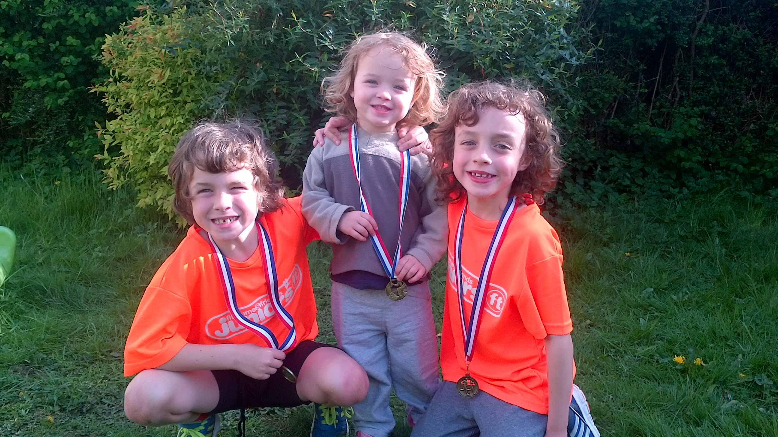

'West Hull Ladies'

'West Hull Ladies'
Doesn't tell the half of it
Unless 'lady' is a new word
For female strength and northern grit
You meet in the executive lounge of Glanford Park
Home of The Iron
Draw by a magnet
To a ferrous place
On a filthy day
Bloody Hell, it's pouring down, you can't go out in that!
Blocked gutters spouting torrents
Car park cataracts and North Lincs Niagaras
Yet here you are
In battered Asics and Versace bin liners
Hunting satellites from the safety of the bar
Then out you go, out together
Across a car park and an industrial estate
To the start line
Each checking the others are OK
And swapping tips
For knicker rub
You will speak
Later
Of the first five easy miles
Before you ditch the bin bag
Before you put your head down
To battle eye-stinging wind and rain
And battle against yourself
Against your aching legs
And that insistent voice that says
'Give up'
Meanwhile
The grandstand
Waits
Shivers
Drips
Then, here they come
Here come the West Hull Ladies
First one, ferret thin, leaning into the final corner
Head up to blast for the line
Another
Hair plastered and jutting chin
Face a blank wall as she wills herself home
This one, like a little tank
Her eyes blazing fierce joy
And two
Hand in hand
Sky-pointing fingers like
Usain-bloody-Bolt himself
And
Most marvellous of all you all
Wait
Each and every one
Each for the others
For the rest
Supporting one another
Holding together, tight and close
Like a good sports bra
So
You West Hull Sisters
I salute you
You and your magnificent, puddle-splashing, joy sharing, triumph-making
Utterly majestic
North Lincs Half
Peter Draper
5th May 2015

Event- Great British Relay

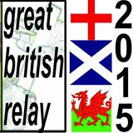
The Great British Relay is a true celebration of running and is the longest continuous unbroken running event lasting some 740hours - about 31 days.

It is split into 595 stages and covers over 7000km travelling around the coastline of mainland Britain. It starts in June and finishes sometime in July.
This is the second year that West Hull Ladies have participated in this wonderful event claiming stage 582. This stage requires us to pick up the ‘baton’ from Barton at 3.37pm on 1st July and run with it to Manchester Street off Hessle Road.

Although things may alter a little we hand it over to the next runner at 4.43pm.

The route is just short of 7 miles and how we did it last year was to have our fastest runners collect the baton in Barton and then meet others at the Humber Bridge car park and then Hessle Square. This should also work this year and enables everyone who wants to participate to be able to do so.

We had a great time in 2014 and I am sure we will this year. We have had quite a few ladies interested so if you haven’t already got the afternoon free maybe its time to think about it.

After we have handed the baton over Jill has kindly invited us back to her home for a celebratory cup of tea. Sounds good to me as I am sure cake will be involved somewhere along the line.

So if you haven’t already let Sandra know you are joining us please do so - the more the merrier.

There is also a T-shirt available to buy costing £12 and they come in Artic White, Desert Sand, Electric Pink, and Sunshine Yellow. The price is the same whether or not you want your name printed on or not.
Sizes are XS S M L XL XXL
8 10 12 14 16 18

Please let Sandra know if you want one and what size/colour. An email will be put out prior to the order going in asking for the money to be paid into the Clubs bank.

If you need any more information please ask or look on the website www.gbrelay.com
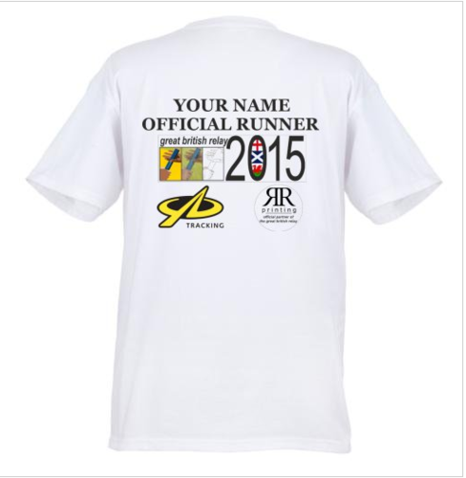

Night out!

West Hull Ladies social – Saturday 6th June
Early drinkers are meeting in Pave on Princes Ave between 5 and 6pm.
Those joining later meet in the Lounge on Princes Ave between 6 and 7pm.
Who knows where it will lead then?! Come with tummy full as we’re not going out for a meal.
See you there!

VEST SALE NOW ON

The club has found that the new style of vest tends to chafe under the arm and has agreed to reduce the price from £16.00 to £10.00. All sizes are available but sales will be on a first come first served basis.

If you wish to order any, please email the club with the completed kit form and once we have received payment Maria will bring the vest to you.

Please note that we are sourcing new vests but want to ensure they are right before purchasing.

2015 RACE DIARY
http://westhullladies.org.uk/races.htm

Free 5K time trial every Saturday 9am: Hull Parkrun or Peter Pan Parkrun

 | Date/Time | Event | Fee | Entry forms | Online entry
April 2015
 | 3rd/10:00 | Bridlington Easter 5 Mile Dash | £13 UKA/£15 | Entry form | online entry (+£1.70)
 | 26th/10:00 | Virgin Money London Marathon | Race Full | Race Full | Race Full
May 2015
 | 3rd/09:00 | North Lincolnshire Half Marathon | £25 UKA/£27 | Online entries only | online entry
 | 10th/11:15 | Beverley 10K | Race Full | Race Full | Race Full
 | 10th/09:30 | Jane Tomlinson Leeds Half Marathon | £29.70 UKA/£31.70 | Online entries only | online entry
Please remember to double check dates, times and entry fees with the official website or the entry form. Zx

Keep checking the website for new races and updates:

NOTE: Club Vests must be worn at any races you enter
under the West Hull Ladies running club name.

Also- please do check the name of the club when entering races on- line.
Look for "West Hull Ladies", and if the name does not appear, it is possible to write in our name manually.

West Hull Ladies Road Running Club
Kit Order Form

FORENAME ___________________________________

SURNAME ___________________________________

ORDER - tick what you require and circle your size Price
- VEST SIZE 10 12 14 16 £16.00
- LONG SLEEVED SIZE 10 12 14 16 £18.50
- HOODIE SIZE XS S M L £20
- HOODIE with ZIP SIZE XS S M L £20
Note on size, M is approximately size 14
- BEANIE HAT £6.50
- PINLESS WHL NUMBER FASTENERS (set of 4) £3.00

DATE Ordered _______________

AMOUNT PAID _______________

Please transfer payments online with your name and marked as ‘Kit to:
Account: 63762742 Sort Code: 20 43 49

Or cheque payable to ‘West Hull Ladies RRC’, and write your name and ‘Kit’ on the back and give to Club Treasurer Linda Dodsworth, 110 The Stray, South Cave, E Yorkshire. HU15 2AL

Sign on receipt of goods _________________________________
DATE _______________

Please complete this form and email to diazmaria@btinternet.com
Thanks.
Maria Kit Officer

